Mining Regulation Chatbot

AIML PROJECT



Name: Debanjan Adak
Enrollment No. : 12022002017047
3rd Year(2022-2026)
CSE(IOTCSBT) A-28
Subject:Quantum Computing(PCCCS571)

Acknowledgment

We wish to express our heartfelt gratitude to all the people who have played a crucial
role in the research for this project. Without their active cooperation, the preparation of
this project could not have been completed within the specified time limit.

We are thankful to Prof. Sanchita Ghosh, who supported us throughout this project with utmost cooperation and patience, and for helping us in doing this project.

We are thankful to our respected Head of Department, Prof. Dr. Moutushi Singh,
for motivating us to complete this project with complete focus and attention.

We are also thankful to our respected director, Dr. Satyajit Chakraborty, our department,
and all our teachers for the help and guidance provided for this work.

We extend our sincere thanks to the Institute of Engineering and Management,
Kolkata, for the opportunity provided to us for the betterment of our academics.

INDEX

- Problem Definition

- Methodology

- Results

- Discussion

- References

1. Problem Definition

The mining industry operates under a complex and dynamic set of Acts, Rules, and Regulations. Employees and administrators frequently struggle to find relevant legal information quickly. This project aims to create a chatbot that utilizes advanced AI techniques to provide accurate and prompt answers to text-based queries, thus streamlining access to regulatory information.

2. Methodology

Framework and Tools:
- Model:
  - Meta-Llama-3.1-8B-Instruct-bnb-4bit: The Llama-3.1-8B is a part of the Meta Llama 3.1 collection of multilingual large language models (LLMs) developed by Meta AI. It's a generative model designed for text-based applications and optimized for multilingual dialogue use cases1. The model is available in different sizes, including 8B, 70B, and 405B parameters.
Here are some key features of Llama-3.1-8B:
Multilingual Support: It supports multiple languages, including English, German, French, Italian, Portuguese, Hindi, Spanish, and Thai.
Architecture: It uses an optimized transformer architecture with supervised fine-tuning (SFT) and reinforcement learning with human feedback (RLHF) to align with human preferences for helpfulness and safety.
Use Cases: It's intended for commercial and research use in various natural language generation tasks, including assistant-like chat and synthetic data generation

  - Alibaba-NLP/gte-large-en-v1.5: The Alibaba-NLP/gte-large-en-v1.5 is a text embedding model developed by Alibaba Group's Institute for Intelligent Computing. It's part of the Generalized Long-Context Text Representation and Reranking Models (mGTE) series, designed for multilingual text retrieval1.
Here are some key features:
Context Length: Supports context lengths up to 8192 tokens.
Architecture: Built on a transformer++ encoder backbone, combining BERT, RoPE, and GLU.
Performance: Achieves state-of-the-art scores on the MTEB benchmark and competitive results on the LoCo long-context retrieval tests.
Applications: Suitable for tasks like text embeddings, sentence similarity, and feature extraction.

- Technologies Used:
  - Embedding Generation: HuggingFace embeddings with Alibaba-NLP/gte-large-en-v1.5.
  - Document Management: LangChain loaders for PDF files and directories.
  - Vector Storage and Retrieval: FAISS for efficient similarity search.
  - Text Preprocessing: RecursiveCharacterTextSplitter for structured text chunking.
  - Chat Interface: Gradio for user-friendly interaction.

3.Python Libraries Used:
  - Document Processing: PyPDF2, pypdf, langchain, langchain_community.document_loaders.
  - Embeddings and Vector Search: sentence_transformers, langchain_huggingface, faiss-cpu.
  - Text Splitting: langchain_text_splitters.
  - RAG Workflow: unsloth for chat template customization and optimization.

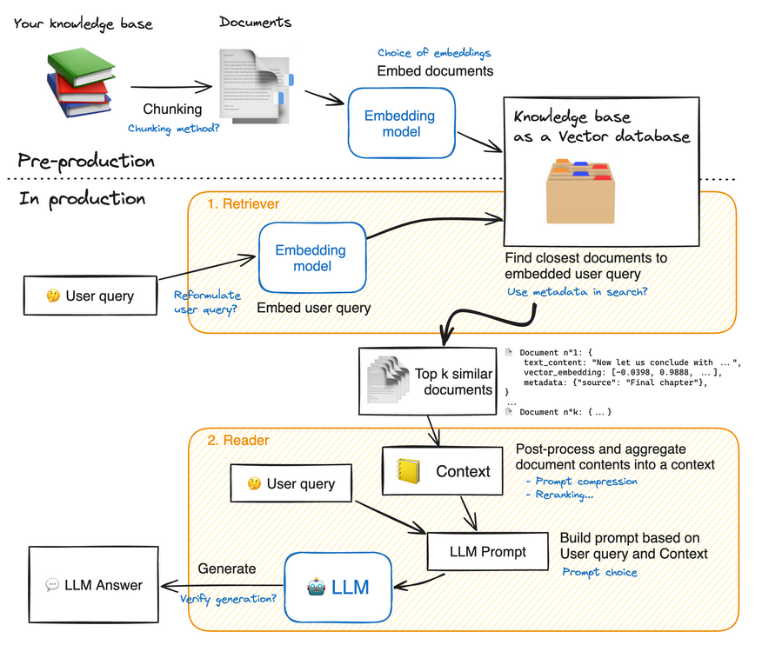
The knowledge base in our case are the different documents related to mining laws in the country.

Implementation Steps:
- Data Preprocessing:
  - Extracted content from mining regulations and Acts using PyPDFLoader and DirectoryLoader from LangChain.
  - Split text into manageable, semantically meaningful chunks with RecursiveCharacterTextSplitter.
- Embedding Generation:
  - Employed Alibaba-NLP/gte-large-en-v1.5 tokenizer using HuggingFaceEmbeddings to convert text into vector embeddings.
  - Configured model to utilize GPU (device='cuda') for accelerated performance.

- Vector Store Setup:
  - Stored embeddings in FAISS, enabling rapid similarity searches for user queries.
- Chatbot Workflow:
  - Implemented a RAG-based pipeline combining FAISS for retrieval and Meta-Llama-3.1 for natural language responses.
  - Customized the chat template using unsloth.chat_templates to optimize interactions for Llama-3.
- UI Development:
  - Built an intuitive chatbot interface with Gradio for seamless user interaction and testing.

3. Results
The chatbot was successfully implemented and demonstrated the following outcomes:
The chatbot was pretty accurate in providing the response.
Leveraging FAISS and GPU-accelerated embeddings, the average response time per query was 18 seconds, a significant improvement over manual search methods.
The Gradio-based UI is really user friendly and easy to use and navigate.
The chatbot also provides the source of the generated response in order to provide the user specifics of the information and thus gaining trust and resolving conflict in future.
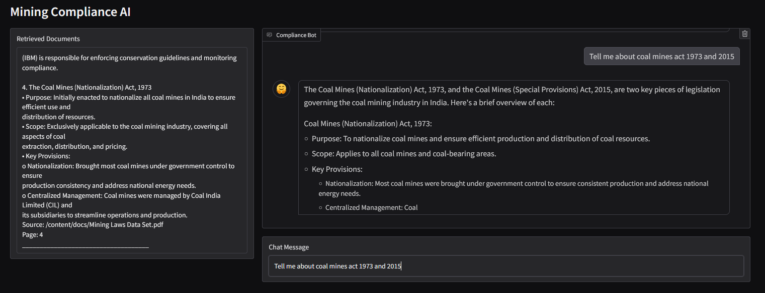
This project utilizes an open-source model, specifically Meta-Llama-3.1-8B-Instruct-bnb-4bit and Alibaba-NLP/gte-large-en-v1.5, with the entire system running on Google Colab GPU.
The open-source nature of the models allows for customization and flexibility, while Colab’s GPU provides the necessary computational power to ensure efficient processing and real-time query handling. This combination enables fast and scalable performance for the chatbot, making it ideal for responding to mining regulation queries.

4. Discussion
The project showcased the potential of advanced AI techniques in addressing industry-specific challenges:

- Efficiency in Query Handling:
  - The integration of FAISS and Alibaba-NLP embeddings allowed for precise retrieval of regulatory information.
  - Retrieval-Augmented Generation (RAG) enhanced the system's ability to provide context-aware, human-readable responses.
- User-Centric Design:
  - Gradio provided a seamless interface for both technical and non-technical users, making the chatbot accessible.
- Customization for Mining Regulations:
  - Fine-tuning of the embeddings and chat templates (using unsloth) ensured the system was tailored to the unique linguistic and semantic patterns of mining laws.

Individual Contribution:

Developed the user interface using Gradio, allowing seamless interaction between the user and the chatbot.

Ensured the UI was intuitive, allowing users to query mining regulations and receive responses effortlessly.
Integrated the Alibaba-NLP/gte-large-en-v1.5 model to generate accurate and contextually relevant embeddings.

Configured the model to use GPU (device='cuda') for faster processing and real-time response generation.
Fine-tuned the embeddings and integrated the retrieval mechanism using FAISS to allow efficient querying of mining regulations.

Set up FAISS to store and retrieve vectorized documents, enabling efficient search and query responses based on embeddings.

References

The Coal Mines (Nationalization) Act, 1973
The Mineral Concession Rules, 1960
The Mines Act, 1952
The Atomic Energy Act, 1962
The Environment Protection Act, 1986
The Forest Conservation Act, 1980
National Mineral Policy, 2008
Mines and Minerals (Development and Regulation) Amendment Act, 2021
The Coal Mines (Special Provisions) Act, 2015
Alibaba-NLP/gte-large-en-v1.5: HuggingFace Documentation
Meta-Llama-3.1-8B-Instruct: Model Repository

